NAME: RAJA RAYYAN AMEER
REG. NO.: 23-CP-25
SECTION: ALPHA
SUBJECT: DATABASE MANAGEMENT SYSTEM
DEPARTMENT: COMPUTER ENGINEERING
TEACHER: SIR SHAHID
LAB TASKS
Task 1: Creating the Hospital Database
Task 2: Creating Core Tables
Task 3: Inserting Sample Data
Task 4: Verifying Database Content
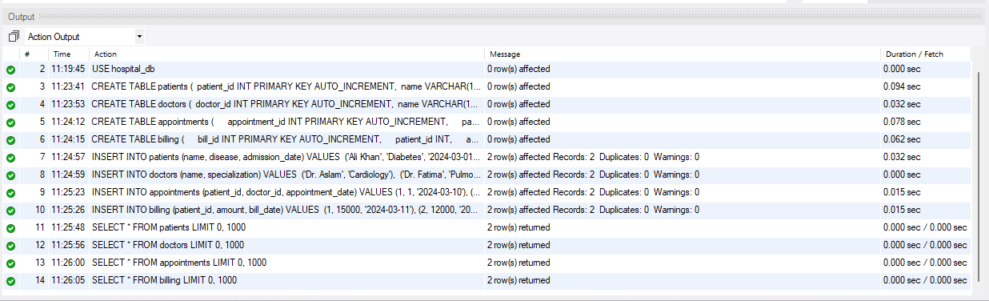
Task 5: Creating a Full Database Backup

Task 6: Inspecting the Backup File
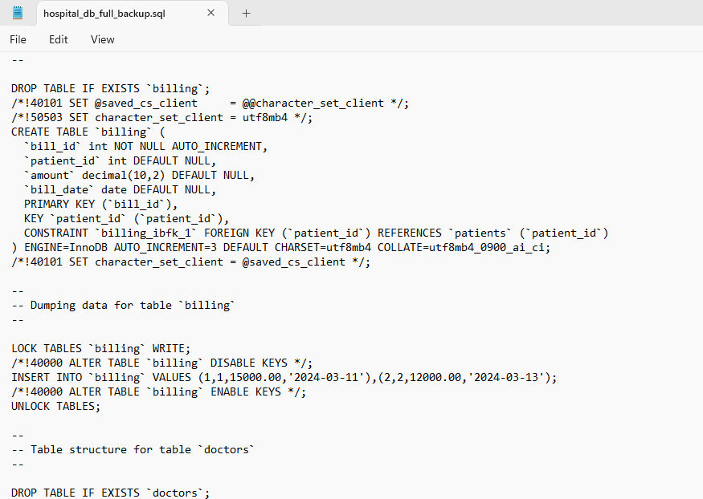
Task 7: Simulating Partial Data Loss
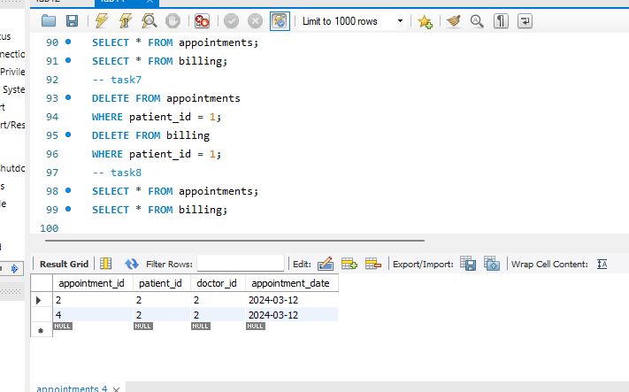
Task 8: Restoring the Database from Backup

Task 9: Verifying Successful Recovery
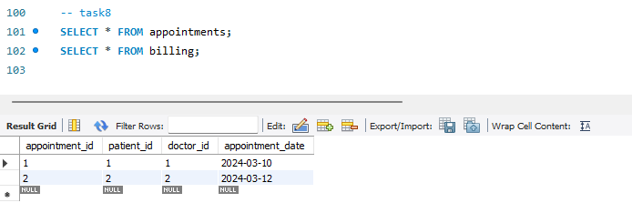
Task 10: Checking and Understanding Binary Logging

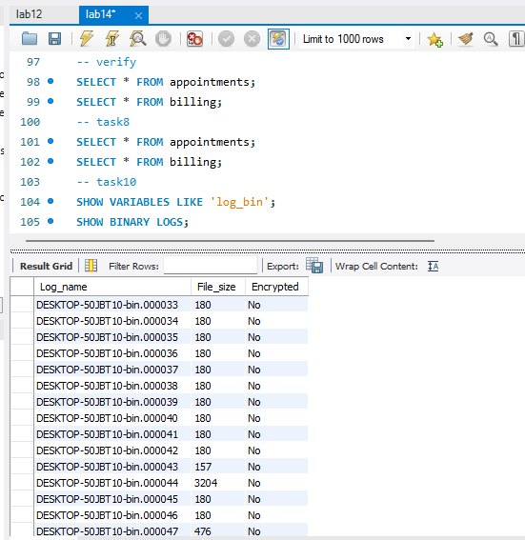

LAB CHALLENGES
- Create a backup containing only the patients and doctors tables, then restore them into a new database named hospital_partial_db.

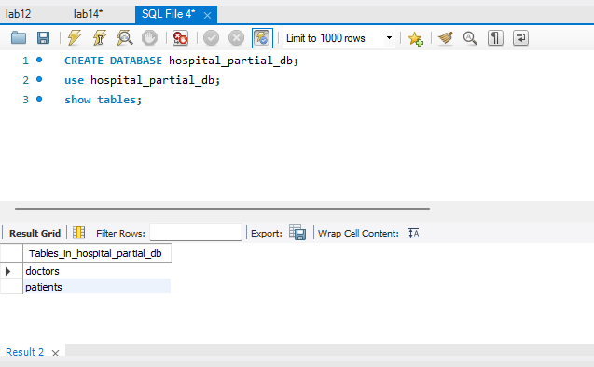
- Insert additional appointment and billing records, restore the database from the earlier full backup, and identify which data is lost and why.
INSERT INTO patients (name, disease, admission_date) VALUES
(‘Ahmed Raza’, ‘Flu’, ‘2024-03-15’),(‘Ayesha Noor’, ‘Migraine’, ‘2024-03-16’);
INSERT INTO doctors (name, specialization)VALUES
(‘Dr. Salman’, ‘Neurology’),(‘Dr. Hina’, ‘General Medicine’);
INSERT INTO appointments (patient_id, doctor_id, appointment_date) VALUES
(3, 3, ‘2024-03-22’),(4, 4, ‘2024-03-23’);
INSERT INTO billing (patient_id, amount, bill_date)VALUES
(3, 8000, ‘2024-03-22’),(4, 9500, ‘2024-03-23’);

Restoring the database from the earlier full backup


After inserting additional records into the appointments and billing tables, the database was restored using an earlier full backup. Once the restoration was completed, the database returned to the state it had at the time the backup was created.
Data Lost
All appointment and billing records that were inserted after the full backup was taken were lost. This includes newly added appointments and billing entries created later in time.
Reason for Data Loss
A full backup captures the database at a specific point in time. Any data added after that time is not included in the backup. When the database is restored from an older backup, all changes made after the backup are overwritten and therefore lost.
Conclusion
This task demonstrates the importance of taking regular backups. Without frequent backups or binary logs, any data added after the last backup cannot be recovered.
- Assume billing records were accidentally deleted at 3:15 PM. Explain step-by-step how binary logs and the full backup would be used to restore the database to 3:14 PM.

Point-in-Time Recovery Using Full Backup and Binary Logs

Step 1: Restore the Latest Full Backup
First, the most recent full backup taken before 3:15 PM is restored.
This brings the database back to the state it had at the time the full backup was created.

Step 2: Enable and Access Binary Logs
Binary logging must be enabled on the MySQL server.
Binary logs contain a chronological record of all database transactions (INSERT, UPDATE, DELETE) performed after the full backup.

Step 3: Identify the Time Range
The accidental deletion occurred at 3:15 PM.
To avoid this deletion, binary logs are applied only up to 3:14 PM.

Step 4: Replay Binary Logs Up to 3:14 PM
All transactions recorded in the binary logs from the backup time up to 3:14 PM are replayed.
Transactions after 3:14 PM, including the DELETE operation at 3:15 PM, are excluded.

Step 5: Verify Restored Data
After applying the binary logs, the database is checked to ensure:
- All valid billing records exist
- The accidental deletion has not been applied
- Design a complete backup strategy for this hospital system, including:
Complete Backup Strategy for Hospital Database System
- Full Backups
- Frequency: Daily (preferably during off-peak hours).
- Purpose: Capture the entire database including all tables (patients, doctors, appointments, billing).
- Storage: Store on a separate server or external storage for disaster recovery.
- Benefit: Allows full restoration of the database if a critical failure occurs.
2. Partial/Table-Level Backups
- Frequency: Weekly or as needed.
- Scope: Critical tables like patients and doctors can be backed up separately.
- Purpose: Faster backups, less storage, useful when only certain data needs protection.
- Benefit: Reduces backup time and storage requirements.
3. Binary Logs
- Enable continuous binary logging.
- Purpose: Records all database transactions (INSERT, UPDATE, DELETE).
- Use Case: Point-in-time recovery (e.g., recover database to just before accidental deletion).
- Benefit: Allows precise restoration without losing valid transactions.
- Backup Verification and Testing
- Test backups regularly by restoring to a test server.
- Purpose: Ensure backups are reliable and not corrupted.
- Benefit: Confirms that restoration will succeed during real disaster recovery.
- Storage and Redundancy
- Keep multiple copies of backups:
  - Local storage for fast access.
  - Off-site/cloud storage for disaster recovery.
- Benefit: Protection against hardware failures, theft, or natural disasters.
- Recovery Plan
- Document recovery procedures:
  - Steps to restore full backup.
  - Steps to restore partial backup.
  - Steps to apply binary logs for point-in-time recovery.
- Benefit: Reduces downtime and ensures staff can restore database quickly.
- Summary
A professional hospital backup strategy includes daily full backups, periodic partial backups for critical tables, continuous binary logging for point-in-time recovery, and regular testing of backup restoration procedures. Multiple storage locations ensure availability and reliability of data.
- Compare logical backups (mysqldump) and physical backups, and explain how binary logs complement both.
Feature | Logical Backup (mysqldump) | Physical Backup
Type | SQL statements (text file) | Raw database files (data & logs)
Speed | Slower (large databases take time) | Faster (copy raw files directly)
Portability | High (can restore on different MySQL versions or servers) | Low (must restore on similar system setup)
Restore Flexibility | Can restore specific tables or rows | Usually restores entire database
Storage | Smaller for small/medium DB | Larger for big DB
Use Case | Small databases, migration, selective table restore | Large databases, disaster recovery, fast full restore

Role of Binary Logs
- Binary logs record all transactions (INSERT, UPDATE, DELETE) after a backup.
- Complement Logical Backups: Enable point-in-time recovery if changes were made after the last mysqldump.
- Complement Physical Backups: Allow replaying transactions to bring database to current state after restoring raw files.
- Benefit: Binary logs ensure minimal data loss and precise recovery regardless of backup type.
THE END

